Experiment 8
Aim
Deploying applications, CI/CD Pipeline, and Cluster Monitoring
Theory
1. Deploying Applications
Application deployment is the process of making an application available for users. It involves building the application, configuring its environment, packaging it into containers, and running it on a server or Kubernetes cluster. Deployment ensures that the application runs reliably and can be accessed by users.
2. CI/CD Pipeline
CI/CD stands for Continuous Integration and Continuous Delivery/Deployment. It automates the process of building, testing, and deploying code whenever changes are made. Tools such as GitHub Actions and Jenkins help detect errors early, reduce manual effort, and speed up software releases.
3. Cluster Monitoring
Cluster monitoring involves tracking the health, performance, and resource utilization of a computing cluster. In Kubernetes, it monitors CPU usage, memory consumption, Pod status, network traffic, and application availability. Monitoring helps identify failures, detect performance bottlenecks, and ensure efficient resource utilization.
Common monitoring tools:
- Prometheus: Collects and stores metrics such as CPU and memory usage.
- Grafana: Visualizes monitoring data through dashboards, graphs, and charts.
- Kubernetes Dashboard: Provides a graphical interface to monitor Pods, Deployments, and Services.
- cAdvisor: Collects container resource usage and performance data.
- Alertmanager: Manages alerts when predefined conditions, such as high CPU usage, are met.
- ELK Stack: Collects, searches, and visualizes application and system logs.
Execution
#.github/workflows/cicd.yml
name: CI/CD Pipeline - Build and Push

on:
push:
branches: [ "main" ]
workflow_dispatch:

jobs:
build-and-push:
runs-on: ubuntu-latest
steps:
- name: Checkout Source Code
uses: actions/checkout@v4

- name: Log in to Docker Hub
uses: docker/login-action@v3
with:
username: ${{ secrets.DOCKERHUB_USERNAME }}
password: ${{ secrets.DOCKERHUB_TOKEN }}

- name: Set up Docker Buildx
uses: docker/setup-buildx-action@v3

- name: Build and Push Docker Image
uses: docker/build-push-action@v6
with:
context: .
push: true
tags: ${{ secrets.DOCKERHUB_USERNAME }}/sample-web-app:v1.0.${{ github.run_number }}

#deployment.yaml
apiVersion: apps/v1
kind: Deployment
metadata:
name: sample-web-app
labels:
app: web
spec:
replicas: 2
selector:
matchLabels:
app: web
template:
metadata:
labels:
app: web
spec:
containers:
- name: web-container
image: nncherian/sample-web-app:v1.0.1
ports:
- containerPort: 80
resources:
requests:
cpu: "100m"
memory: "128Mi"
limits:
cpu: "250m"
memory: "256Mi"

#Dockerfile
FROM nginx:alpine
COPY index.html /usr/share/nginx/html/index.html
EXPOSE 80
CMD ["nginx", "-g", "daemon off;"]

CI/CD Pipeline
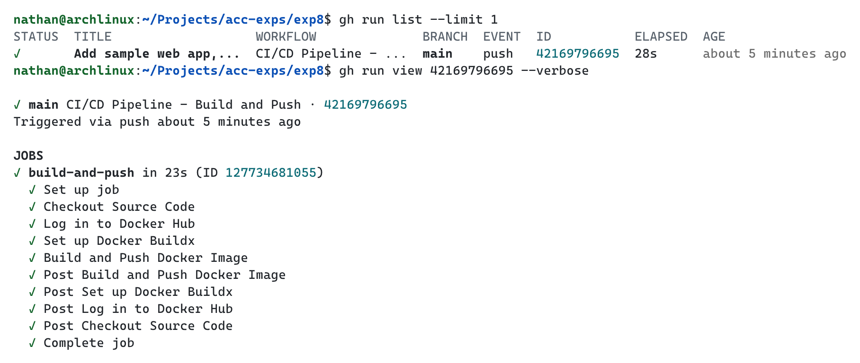

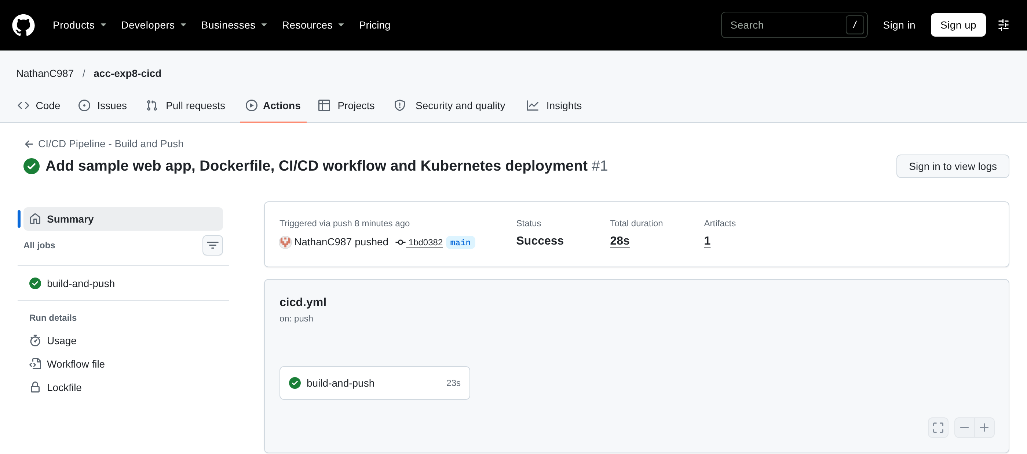

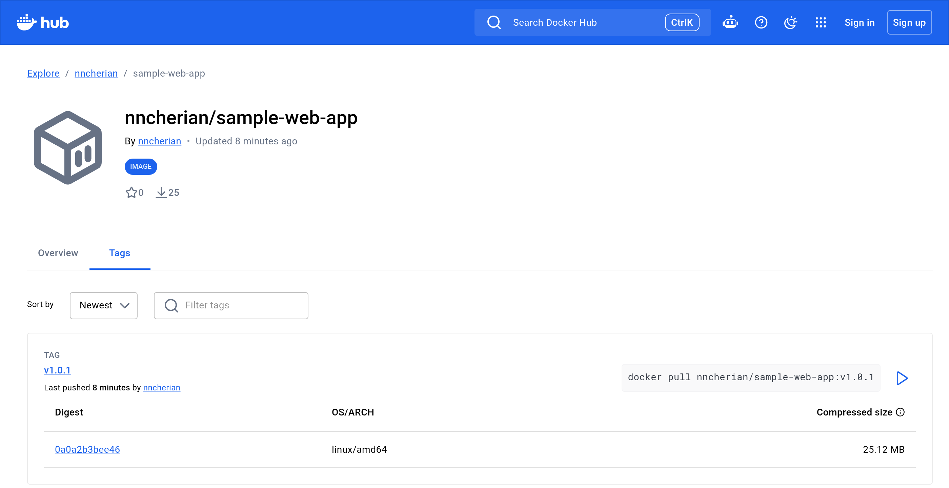

Application Deployment
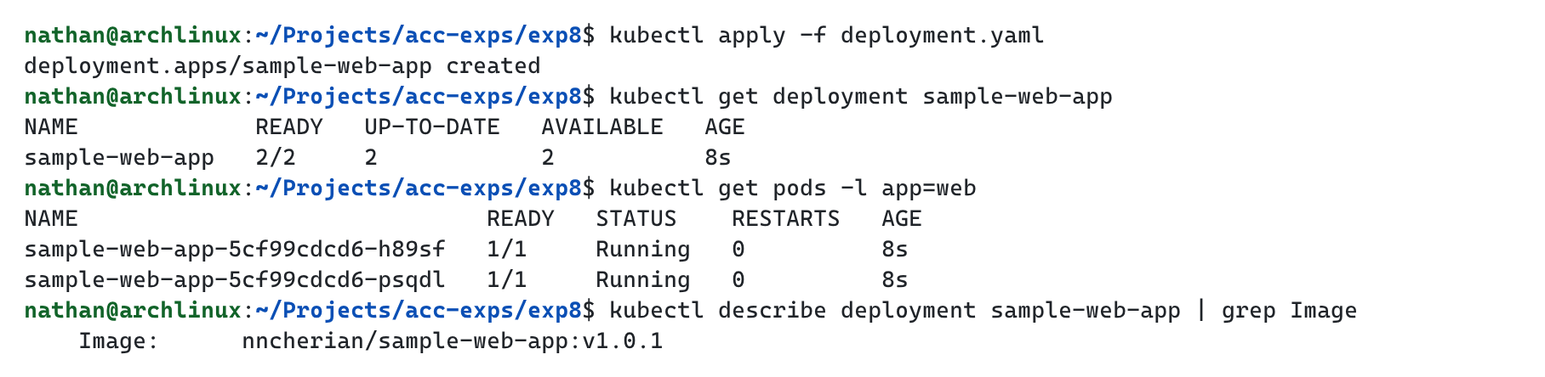

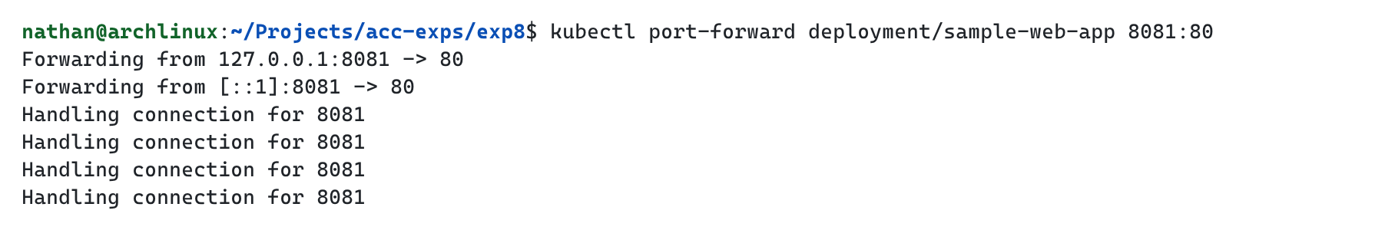

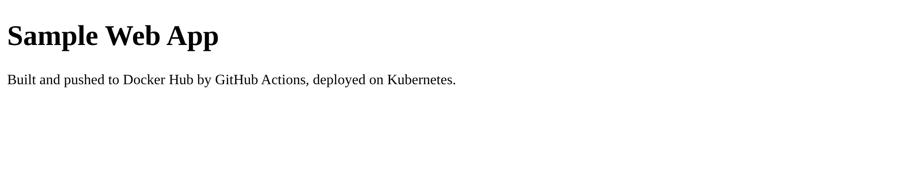

Monitoring Setup
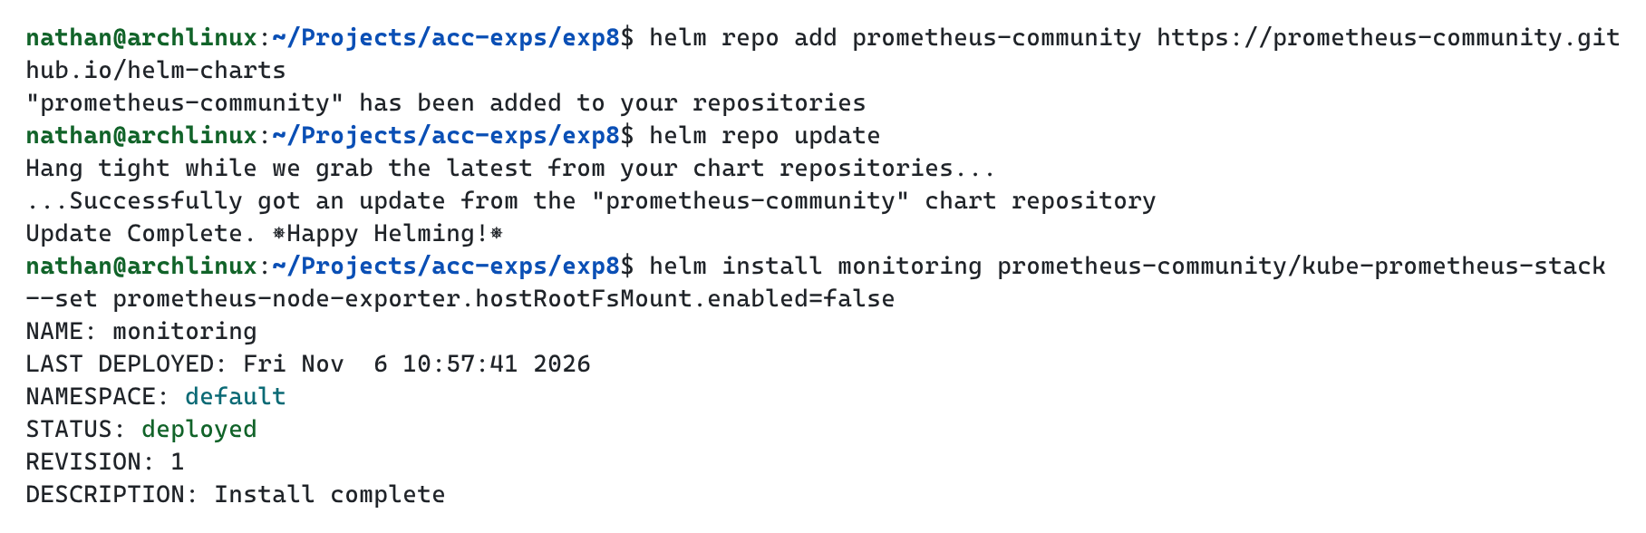

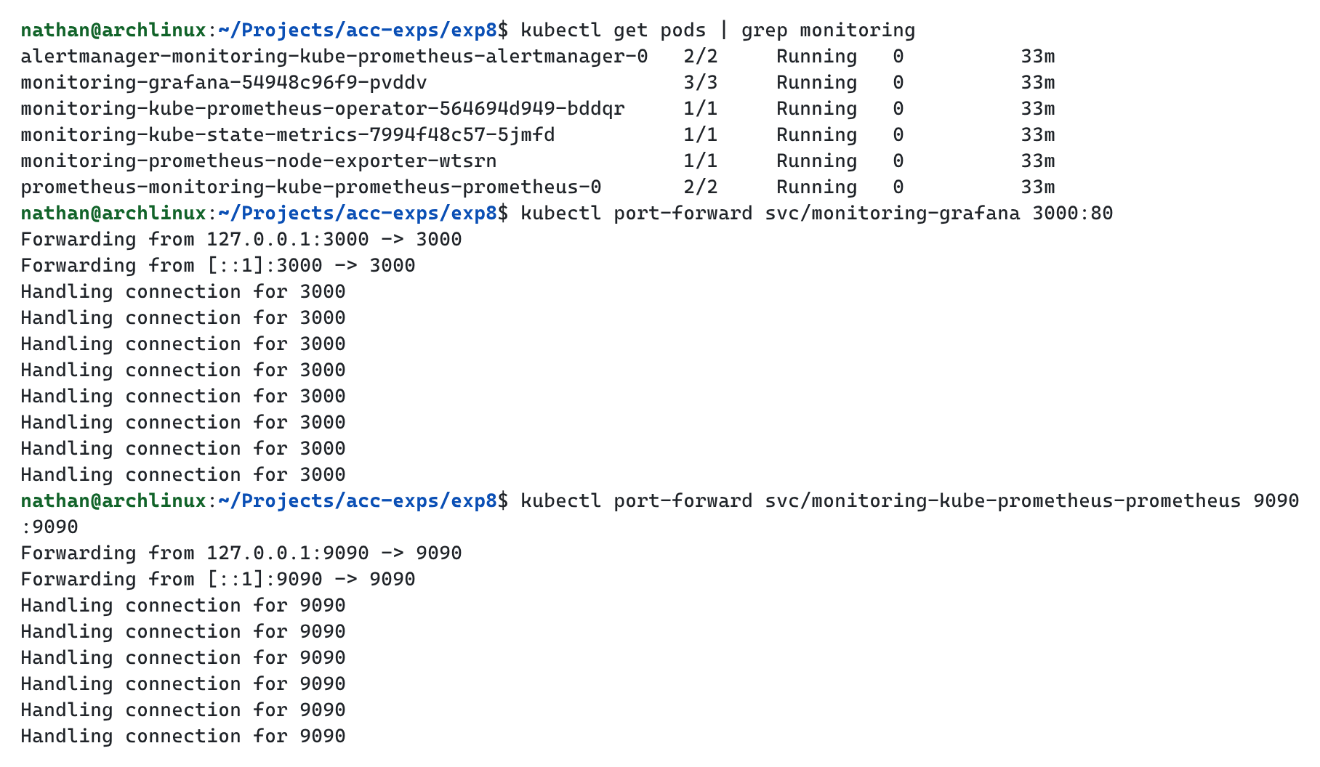

Kubernetes Dashboard
Provides a graphical view of the Workloads running in the cluster.
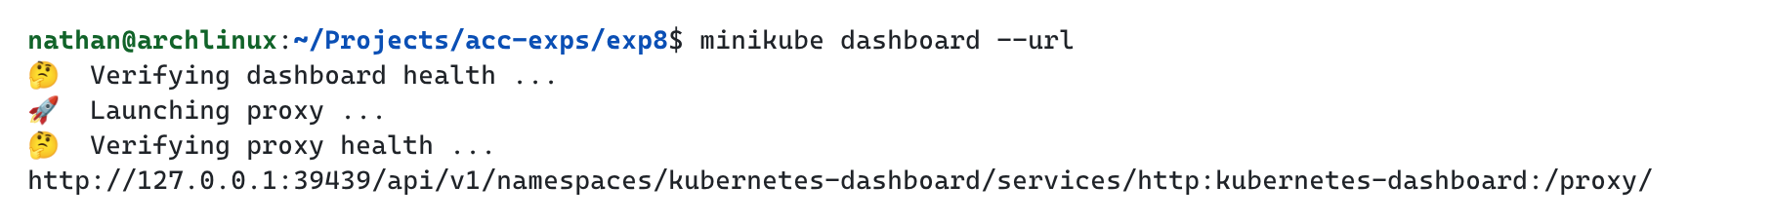

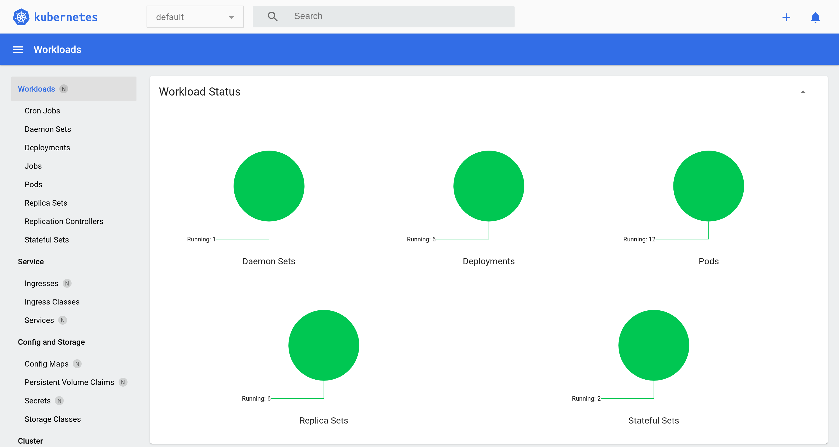

Grafana
Visualizes cluster metrics using dashboards and graphs.
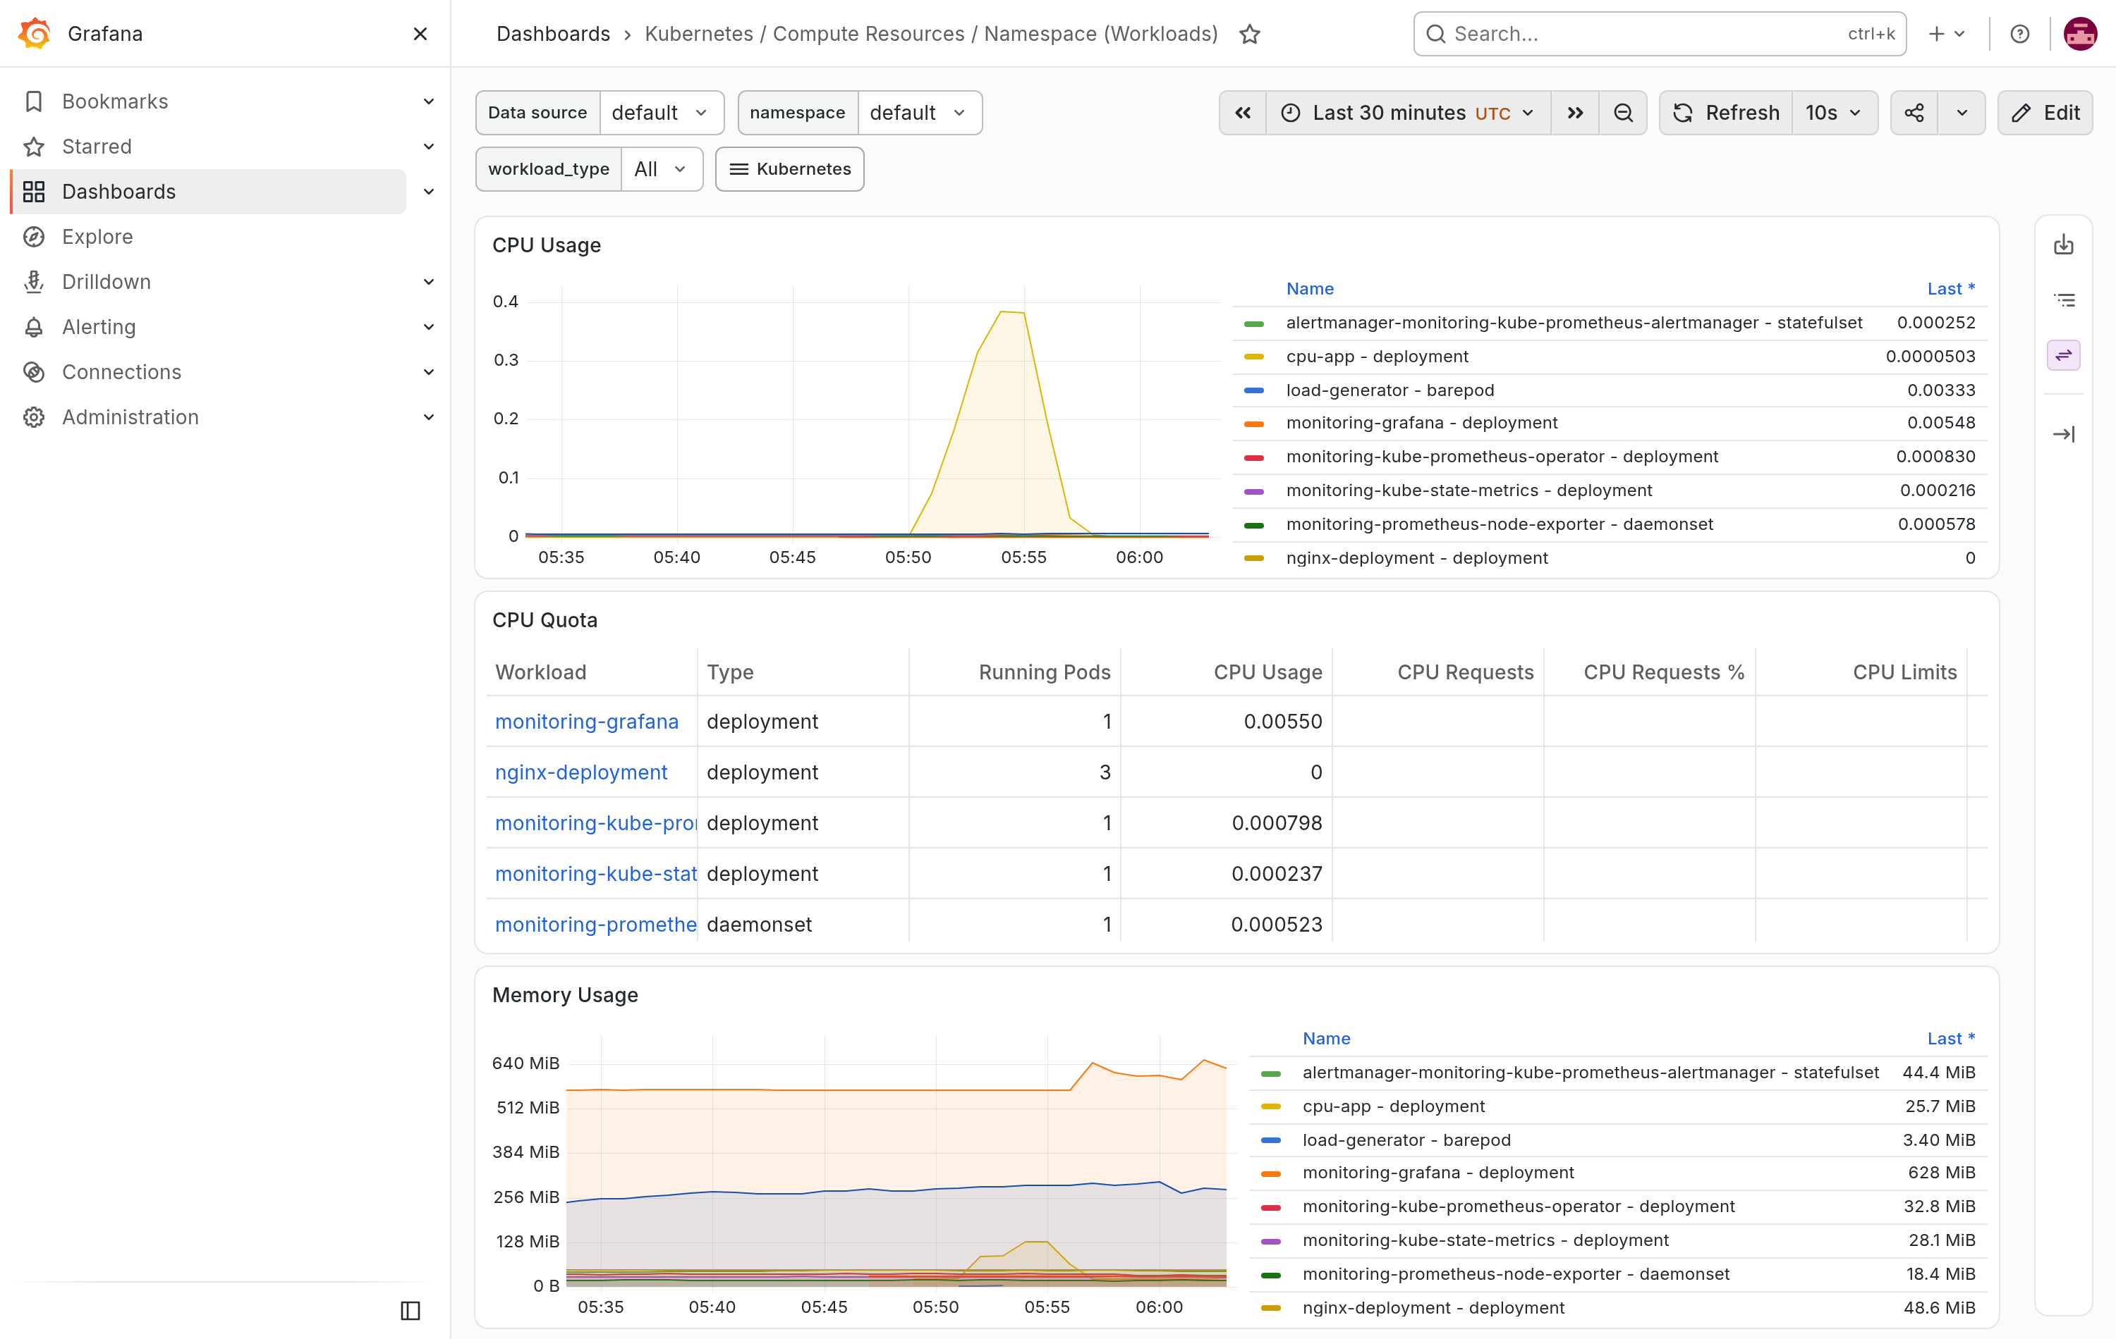

Prometheus
Collects and stores metrics from the cluster, which can be queried and graphed.
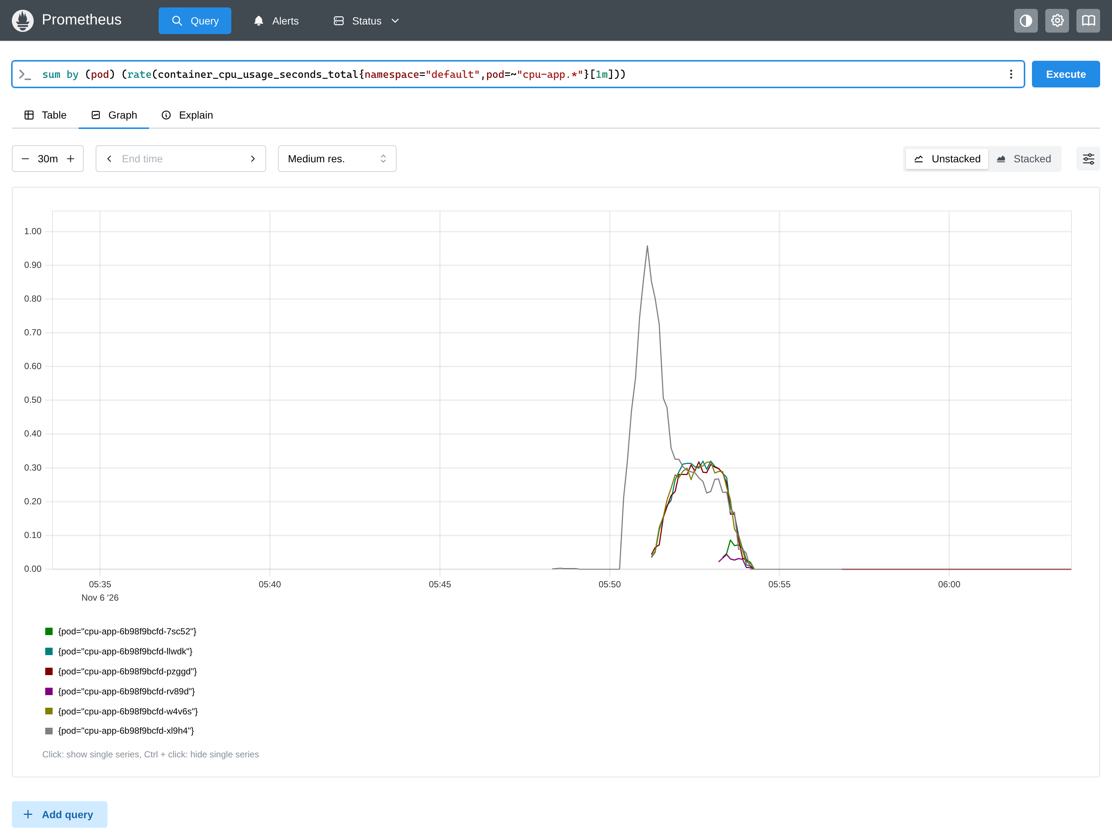

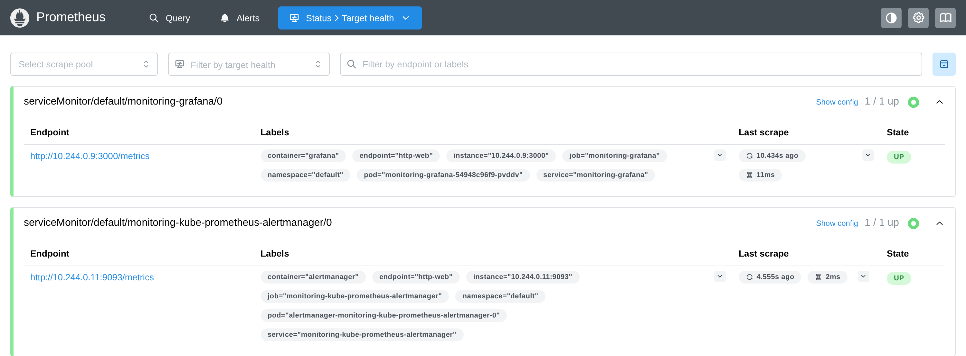

Conclusion
Thus, the experiment successfully demonstrated deploying an application, a CI/CD pipeline, and cluster monitoring. A GitHub Actions workflow built the application image and pushed it to Docker Hub, the image was deployed on Kubernetes, and Prometheus, Grafana, and the Kubernetes Dashboard were used to monitor the cluster.

